Rob – you keep forgetting to make these changes. PLEASE take a few more minutes to run through the site and make certain everything is correct. You didn’t even realize that the page for Early Childhood Decay was the exact same page as the Teething page. Please give this site the attention to detail it needs. The changes I am wanting are the same ones that I have previously stated. As I said before I have been more than patient with all the time it has taken. I want this done now.

1.) Add this information to the “Early Childhood Decay” tab under the Treatment Icon

Baby Bottle Tooth Decay (Early Childhood Caries)

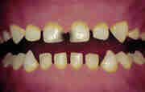 | 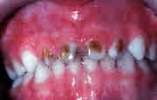 | 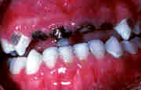
Mild Decay | Moderate Decay | Severe Decay

What is baby bottle tooth decay?
Decay in infants and children is called baby bottle tooth decay. It can destroy the teeth and most often occurs in the upper front teeth. But other teeth may also be affected.
What causes baby bottle tooth decay?
Decay occurs when sweetened liquids are given and are left clinging to an infant's teeth for long periods. Many sweet liquids cause problems, including milk, formula and fruit juice. Bacteria in the mouth use these sugars as food. They then produce acids that attack the teeth. Each time your child drinks these liquids, acids attack for 30 minutes or longer. After many attacks, the teeth can decay.
It's not just what you put in your child's bottle that causes decay, but how often — and for how long a time. Giving your child a bottle of sweetened liquid many times a day isn't a good idea. Allowing your child to fall asleep with a bottle during naps or at night can also harm the child's teeth.
Why are baby teeth important?
Your child's baby teeth are important. Children need strong, healthy teeth to chew their food, speak and have a good-looking smile. Baby teeth also keep a space in the jaw for the adult teeth. If a baby tooth is lost too early, the teeth beside it may drift into the empty space. When it's time for the adult teeth to come in, there may not be enough room. This can make the teeth crooked or crowded.
How can baby bottle tooth decay be prevented?
Sometimes parents do not realize that a baby's teeth can decay soon after they appear in the mouth. By the time decay is noticed, it may be too late to save the teeth. You can help prevent this from happening to your child by following the tips below:
- Because cavity causing bacteria are transmitted soon after the first teeth erupt, decreasing the mother's bacteria levels may decrease the child's risk of developing Early Childhood Caries. We recommend that parents, including expectant parents, be encouraged to visit a dentist to ensure their own oral health
- After each feeding, wipe the baby's gums with a clean gauze pad. Begin brushing your child's teeth when the first tooth erupts. Clean and massage gums in areas that remain toothless, and begin flossing when all the baby teeth have erupted, usually by age 2 or 2½.
- Never allow your child to fall asleep with a bottle containing milk, formula, fruit juice or sweetened liquids. Infants should finish their bedtime and naptime bottle before going to bed. Also, unrestricted and at-will nocturnal breastfeeding after eruption of the child’s first tooth can lead to an increased risk of decay.
- If your child needs a comforter between regular feedings, at night, or during naps, give the child a clean pacifier recommended by your dentist or physician. Never give your child a pacifier dipped in any sweet liquid.
- Avoid filling your child's bottle with liquids such as sugar water, juice, and soft drinks.
- If your local water supply does not contain fluoride (a substance that helps prevent tooth decay), ask your dentist how your child should get it.
Start dental visits by the child's first birthday. Make visits regularly. If you think your child has dental problems, take the child to the dentist as soon as possible

2). Move the “Teething” link from the top of the Patients drop down menu to just below the link for “Infant Formula”

- Remove all the existing pictures from the “Teething” page and put in DS3-0111 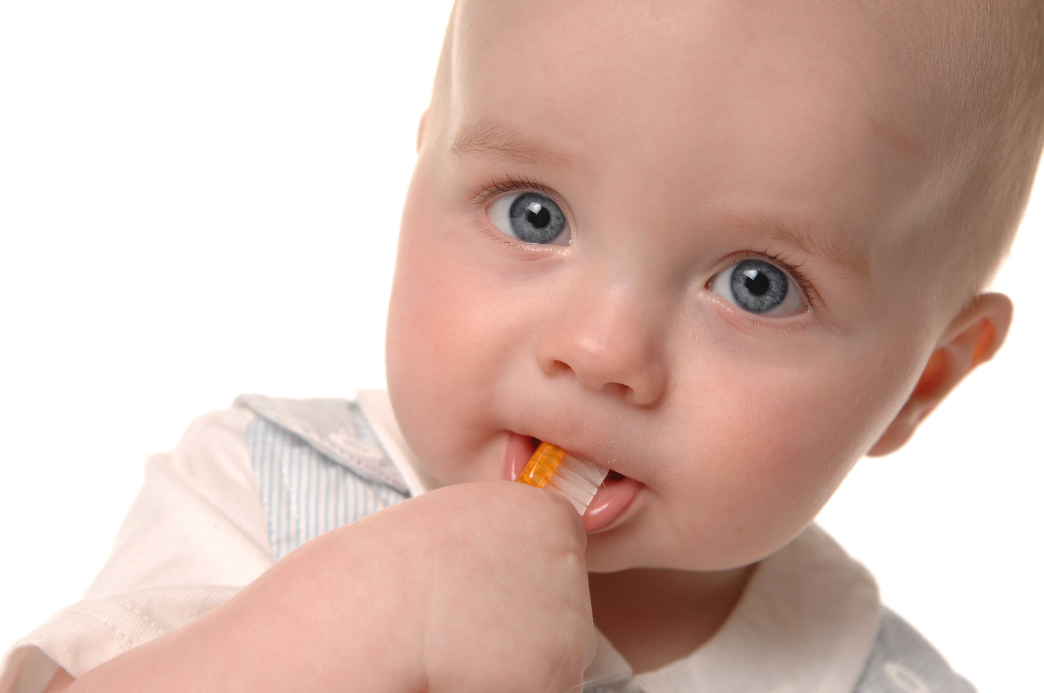
- Put picture on page with “Importance of Dental Health  DSC_0064F8x8 (Remove the other pictures from the page
- What do I have to do to convert this website to HTML format? Is it hard? Let me know

